NUMBER 3 — INFORMATION ARCHITECTURE
Smart Cafeteria App
Role: Information Architecture Lead

1. Role Responsibility
The Information Architecture Lead builds the task flow, user journey and interaction-flow diagram, and plans the screen map before Balsamiq wireframing starts.

2. Main User Journey
The main journey is designed around a cafeteria customer who signs in, browses food, selects an item, adds it to a cart, checks out, pays, receives confirmation, and tracks the order. Secondary screens provide order history and profile/settings access.
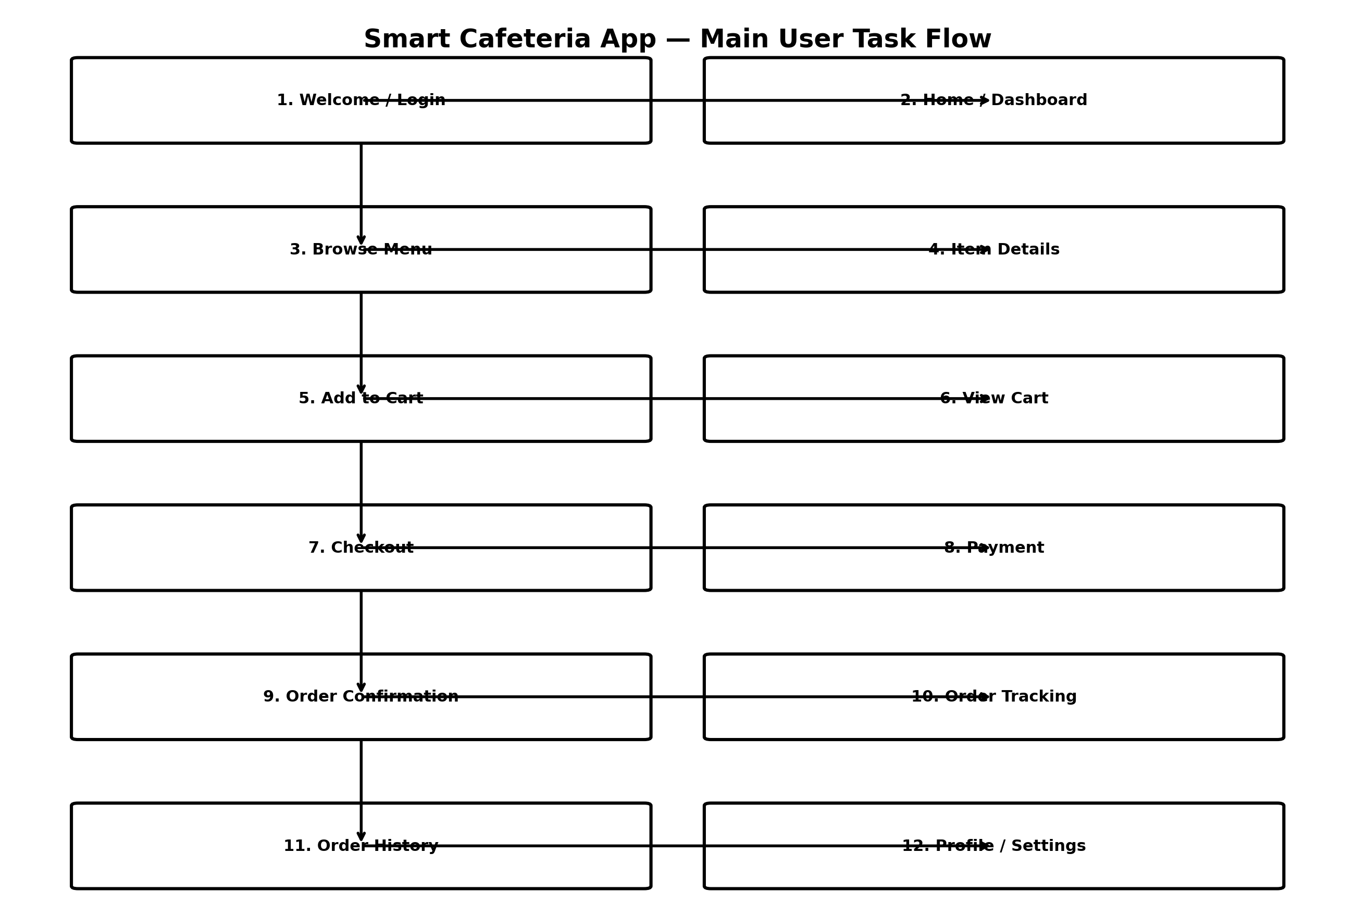

3. Screen Map — 12 Linked Screens
# | Screen | Purpose
1 | Welcome / Login | Entry point; user signs in or continues to registration.
2 | Home / Dashboard | Main navigation to menu, cart, orders and profile.
3 | Browse Menu | Displays available cafeteria meals and categories.
4 | Item Details | Shows food description, price, quantity and add-to-cart action.
5 | Add to Cart | Confirms the selected item and quantity before cart review.
6 | View Cart | Shows selected items, quantities, subtotal and checkout action.
7 | Checkout | Collects pickup/delivery details and order summary.
8 | Payment | Allows the user to select and complete a payment method.
9 | Order Confirmation | Confirms successful order placement and provides order number.
10 | Order Tracking | Shows current order status and estimated readiness/delivery.
11 | Order History | Lists previous and current orders for quick access.
12 | Profile / Settings | Manages user details, preferences and account settings.

4. Interaction / Navigation Logic
From | Link | To
Welcome / Login | → | Home / Dashboard
Home / Dashboard | → | Browse Menu
Browse Menu | → | Item Details
Item Details | → | View Cart / Add to Cart
View Cart | → | Checkout
Checkout | → | Payment
Payment | → | Order Confirmation
Order Confirmation | → | Order Tracking
Home / Dashboard | → | Order History
Home / Dashboard | → | Profile / Settings
Order History | → | Order Tracking / Order Details
Profile / Settings | → | Home / Dashboard

5. Key Decision Points
- If the user is not logged in, the app directs them to Login/Register.
- From the Home screen, the user can enter the Menu, Cart, Orders, or Profile.
- From Item Details, the user can add an item to the Cart or return to the Menu.
- The Cart leads to Checkout only after the user has selected at least one item.
- Checkout leads to Payment, then successful payment leads to Order Confirmation.
- Order Confirmation leads to Order Tracking, while Order History provides access to previous orders.

6. IA Deliverable Checklist
☐ Task flow / user journey is defined.
☐ Main interaction flow is mapped.
☐ 12 screens are identified before Balsamiq wireframing.
☐ Primary navigation paths are connected.
☐ Checkout and payment flow is clearly separated.
☐ Order confirmation and tracking are included.
☐ Secondary navigation for Order History and Profile/Settings is included.
☐ All diagram boxes use complete closed rectangles and full solid connector lines.

Prepared for Number 3 — Information Architecture Lead

